**Assignment – 7**

**1. Write a Java program in which a total of 4 threads should run. Set different priorities for the thread.**

public class demo {

public static void main(String[] args) {

System.out.println("Name : Gokul Sarkar \nRoll No : 46");

Thread thread1 = new Thread(new MyRunnable(), "Thread 1");

Thread thread2 = new Thread(new MyRunnable(), "Thread 2");

Thread thread3 = new Thread(new MyRunnable(), "Thread 3");

Thread thread4 = new Thread(new MyRunnable(), "Thread 4");

thread1.setPriority(Thread.MIN_PRIORITY);

thread2.setPriority(Thread.NORM_PRIORITY);

thread3.setPriority(Thread.NORM_PRIORITY);

thread4.setPriority(Thread.MAX_PRIORITY);

thread1.start();

thread2.start();

thread3.start();

thread4.start();

}

private static class MyRunnable implements Runnable {

public void run() {

System.out.println(" " + Thread.currentThread().getName() + " is running with priority " + Thread.currentThread().getPriority());

}

}

}

**Output:**

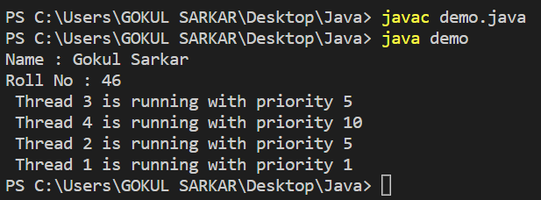

**2. Write a Java Program to Create a Thread that Implements the Runnable Interface.**

class MyRunnable implements Runnable {

public void run() {

System.out.println("Thread is running");

}

}

public class demo1 {

public static void main(String[] args) {

System.out.println("Name : Gokul Sarkar \nRoll No : 46");

MyRunnable myRunnable = new MyRunnable();

Thread myThread = new Thread(myRunnable);

myThread.start();

}

}

**Output:**

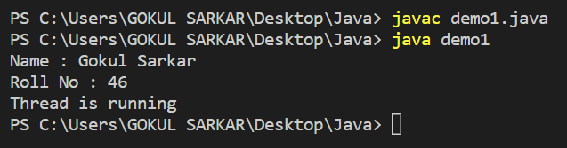

**3. Write a Java Program to Check the Priority Level of a Thread.**

public class demo2 {

public static void main(String[] args) {

System.out.println("Name : Gokul Sarkar \nRoll No : 46");

Thread myThread = new Thread();

int priority = myThread.getPriority();

System.out.println("Thread priority: " + priority);

}

}

**Output:**

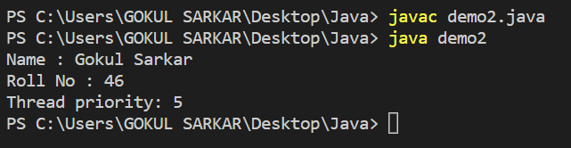

**4. Write a Java Program Defining Thread By Extending the Thread class.**

class MyThread extends Thread {

public void run() {

System.out.println("Thread is running");

}

}

public class demo3 {

public static void main(String[] args) {

System.out.println("Name : Gokul Sarkar \nRoll No : 46");

MyThread myThread = new MyThread();

myThread.start();

}

}

**Output:**

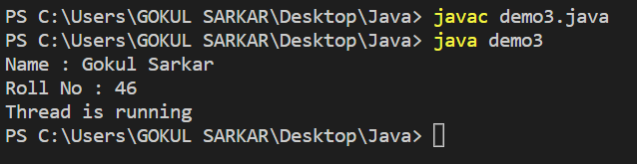

**5. Write a Java Program to Get the Name of a Running Thread.**

public class demo4 {

public static void main(String[] args) {

Thread thread = new Thread() {

public void run() {

String threadName = Thread.currentThread().getName();

System.out.println("Thread name: " + threadName);

}

};

thread.start();

String mainThreadName = Thread.currentThread().getName();

System.out.println("Main thread name: " + mainThreadName);

System.out.println("Name : Gokul Sarkar \nRoll No : 46");

}

}

**Output:**

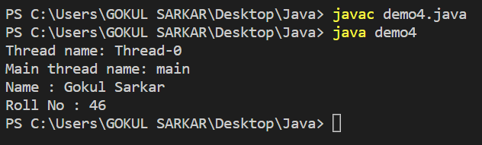

**6. Write a Java Program to Stop a Thread.**

public class demo5 {

public static void main(String[] args) throws InterruptedException {

MyThread myThread = new MyThread();

myThread.start();

Thread.sleep(5000);

myThread.interrupt();

}

}

class MyThread extends Thread {

public void run() {

while (!isInterrupted()) {

System.out.println("Thread is running...");

System.out.println("Name : Gokul Sarkar Roll No : 46");

try {

Thread.sleep(1000); // Sleep for 1 second

}

catch (InterruptedException e) {

return;

}

}

}

}

**Output:**

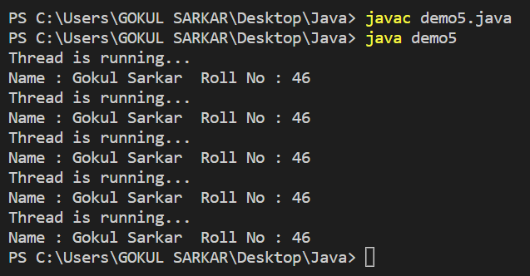

**7. Write a Java Program to Check Whether Define a Thread Class Without Defining run( ) Method in the Class.**

class MyThread extends Thread {

}

public class demo6 {

public static void main(String[] args) {

System.out.println("Name : Gokul Sarkar \nRoll No : 46");

MyThread myThread = new MyThread();

myThread.start();

}

}

**Output:**

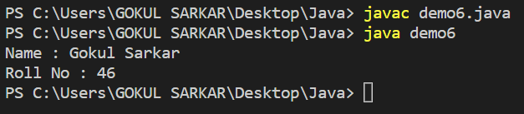

**8. Write a Java Program to Show that Method Will be Verified Whether it is Synchronized or Not.Define a Thread Class Without Defining run() Method in the Class.**

public class Main {

public synchronized void synchronizedMethod() {

System.out.println("This method is synchronized");

}

public void nonSynchronizedMethod() {

System.out.println("This method is not synchronized");

}

public static void main(String[] args) {

System.out.println("Name : Gokul Sarkar \nRoll No : 46");

Main main = new Main();

main.synchronizedMethod();

main.nonSynchronizedMethod();

Thread t1 = new Thread(() -> {

main.synchronizedMethod();

});

Thread t2 = new Thread(() -> {

main.synchronizedMethod();

});

t1.start();

t2.start();

Thread t3 = new Thread(() -> {

main.nonSynchronizedMethod();

});

Thread t4 = new Thread(() -> {

main.nonSynchronizedMethod();

});

t3.start();

t4.start();

}

}

**Output:**

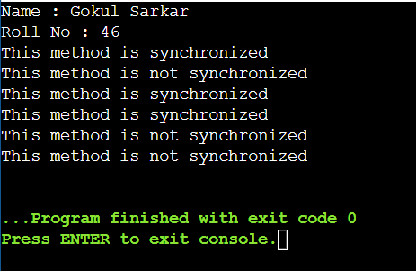

**9. Create 4 threads with priority 1,3,5,7 respectively. Update a counter in each of the threads for 10 ms. Print the final value of the count for each thread.**

public class demo9 {

public static void main(String[] args) {

CounterThread t1 = new CounterThread("Thread 1", 1);

CounterThread t2 = new CounterThread("Thread 2", 3);

CounterThread t3 = new CounterThread("Thread 3", 5);

CounterThread t4 = new CounterThread("Thread 4", 7);

t1.start();

t2.start();

t3.start();

t4.start();

try {

t1.join();

t2.join();

t3.join();

t4.join();

} catch (InterruptedException e) {

System.out.println("Main thread interrupted.");

}

System.out.println("Name : Gokul Sarkar \nRoll No : 46");

System.out.println(t1.getName() + " count: " + t1.getCount());

System.out.println(t2.getName() + " count: " + t2.getCount());

System.out.println(t3.getName() + " count: " + t3.getCount());

System.out.println(t4.getName() + " count: " + t4.getCount());

}

}

class CounterThread extends Thread {

private int count = 0;

public CounterThread(String name, int priority) {

super(name);

setPriority(priority);

}

public int getCount() {

return count;

}

public void run() {

for (int i = 0; i < 5; i++) {

count++;

try {

Thread.sleep(10);

} catch (InterruptedException e) {

System.out.println(getName() + " interrupted.");

}

}

}

}

**Output:**

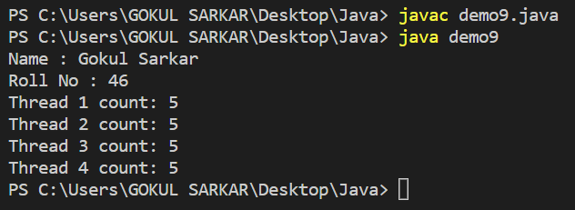

**10.Write a Java Program to Use Method Level Synchronization.**

class Counter {

private int count;

public synchronized void increment() {

count++;

}

public int getCount() {

return count;

}

}

class CountThread extends Thread {

private Counter counter;

private int times;

public CountThread(Counter counter, int times) {

this.counter = counter;

this.times = times;

}

public void run() {

for (int i = 0; i < times; i++) {

counter.increment();

}

}

}

public class demo8 {

public static void main(String[] args) {

Counter counter = new Counter();

CountThread thread1 = new CountThread(counter, 10000);

CountThread thread2 = new CountThread(counter, 20000);

thread1.start();

thread2.start();

try {

thread1.join();

thread2.join();

} catch (InterruptedException e) {

System.out.println("Thread interrupted");

}

System.out.println("Name : Gokul Sarkar \nRoll No : 46");

System.out.println("Final count: " + counter.getCount());

}

}

**Output:**

